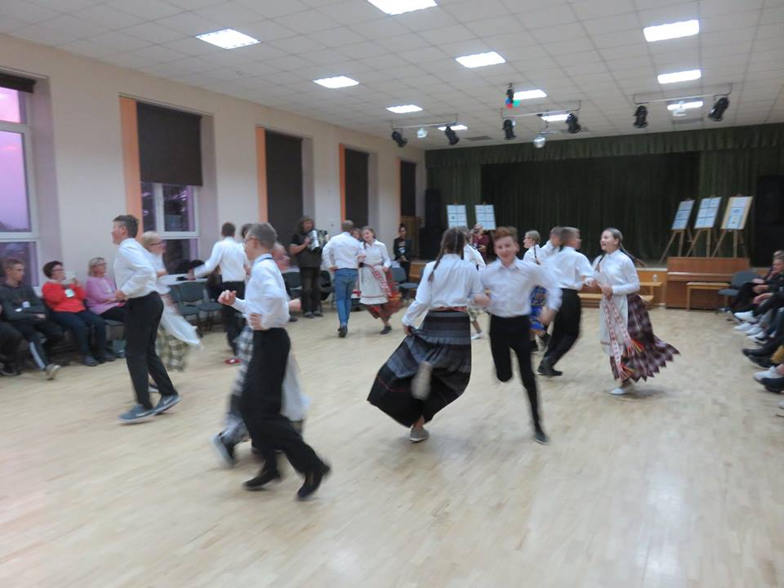
Menin ylös kukkulalle,
Katsoin veteen.
Kun vesi hehkuu,
Laventeli huojuu.

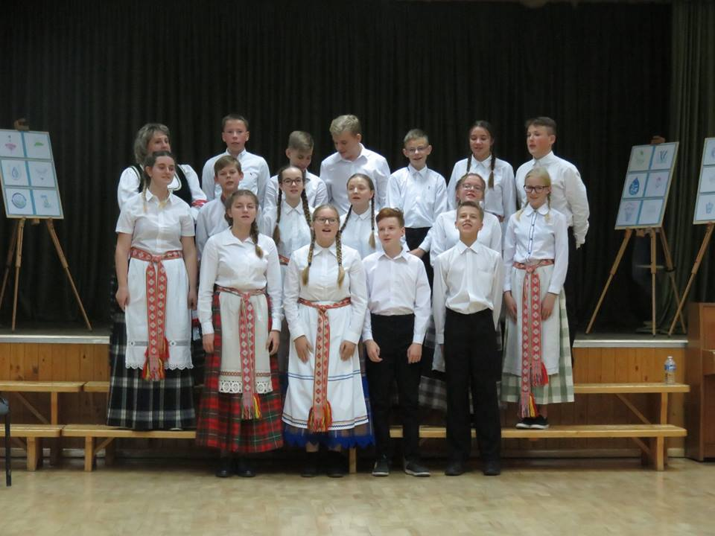
Ma tõusin mäele
Ma vaatasin vette.
Kus vesi hõõgus
Lavendel kiikus

Я поднялся на гору
Посмотрел на воду.
Где сияла вода
И качалась лаванда.

Aš užeisiu ant kalno
I went up the hill,
Looked at the water.
Where the water glows,
A Lavender swings.
Pažiūrėsiu vandenin.
Kur vanduo liūliuoja
Levandrėla siūbuoja.

The players are divided into two equal sets, one goes out.
Inside, each chooses a partner in the room.
Outside people come one by one to bow to whom they want.
If one of them bows to someone who has not picked him up, he has to say "Water in a boot" and he has to hop out of the room on one foot.
If one of them bows to the right guy, the guy has to say "The sun is shining" and he can stay inside. Everyone has to go hopping until they hit the right one. Once everyone has found their partner, teams will swap.

