Trip to Klaipeda

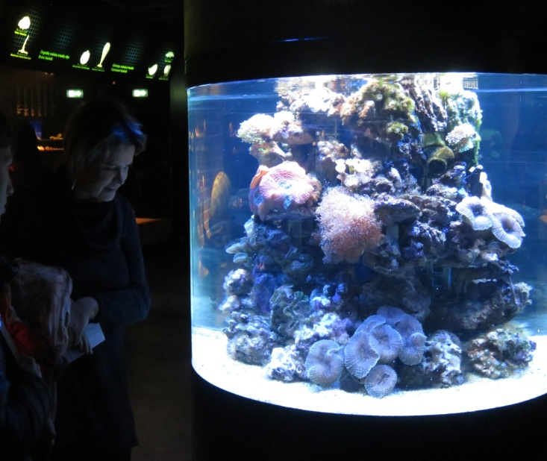
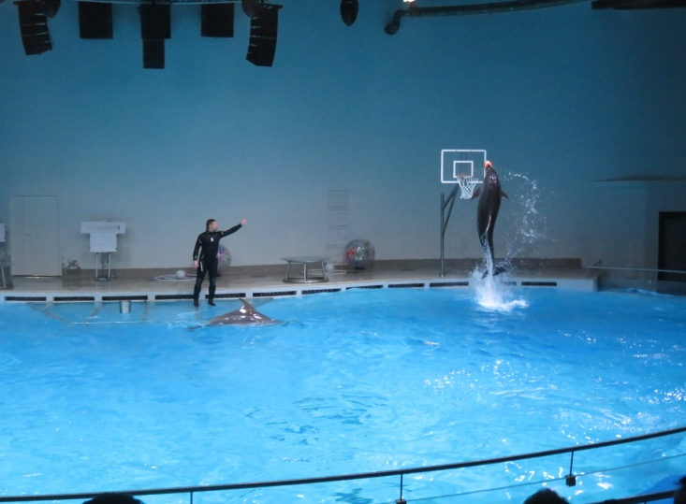
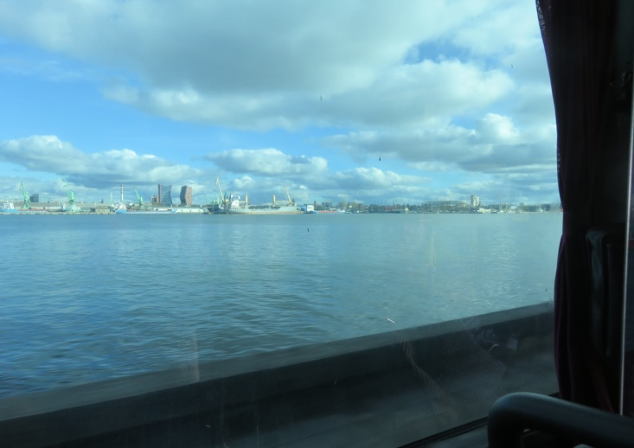
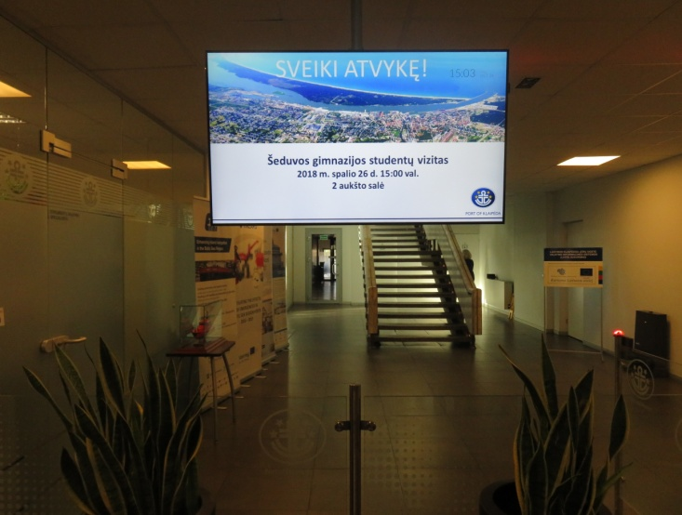
The day started in the school at 6:30am. After all project members and our school students gathered the bus came and the trip started. Even though the ride was long it wasn’t tedious because the music made us awake. Our first stop was in the Maritime Museum. Because it’s in Smiltyne we had to get across by ferry. While we were swimming we were able to see a small part of the port. Eventually, our bus got to the museum, the dolphin and sea lion show was the first thing our group saw which, by the way, was stunning. We learned some things about dolphins and sea lions but there was one minus – they spoke in the Lithuanian language so our project members from other countries couldn’t understand. When the performance was over we met our guide. He introduced us to the profound parts of the sea, venomous fishes and this time in English. After visiting the sea museum our guide told us more historical facts about Klaipeda and we left Smiltyne. For the second part of the journey we drove to the center of Klaipeda port. There we learned about our port authorities and what its purpose is and activities. Of course, at this part we all were a little bit exhausted because the week was long. But we still managed to have fun in Acropolis. Of course, the time came to go home and there were more music and laugh than before. I was a little bit nervous at first because I didn’t think that our project members are going to be so amiable and open minded. It was a pleasure to communicate with from other countries people from other countries, to find the differences and similarities in our economy, studies and everyday life.
